**Project Report for Video game Analysis**

1. **INTRODUCTION**
   1. Overview

Video game sales analysis is the process of collecting and analyzing data about the sales of video games in order to understand market trends and consumer behavior. This type of analysis can be useful for a variety of purposes, including identifying the most popular games and genres, predicting future sales, and developing marketing strategies.Video game sales analysis typically involves collecting data from Kaggle sources. It was generated by a scrape of vgchartz.com. This data may include information about the number of units sold, the retail price, and the platforms on which the games are played. Once the data has been collected, it is typically analyzed using tableau. The results of the analysis can be used to identify trends and patterns in the market, and to make informed decisions about the development and marketing of video games.Video game sales analysis may be conducted by game developers, publishers, retailers, and other industry professionals. It is an important part of the video game industry, as it helps to understand the needs and preferences of consumers and to identify opportunities for growth and innovation.

Analysing sales data from more than 16,500 games. This dataset contains a list of video games with sales greater than 100,000 copies.

* 1. Purpose

The goal of a game analysis is not to establish how good or bad a game is, but highlight and rationalize the aspects that make the game worth studying and contribute to understanding videogames better. Thus, you will be expected to write a critique, which is very different from a review for a blog.

1. **Problem Definition & Design Thinking**
   1. Empathy Map

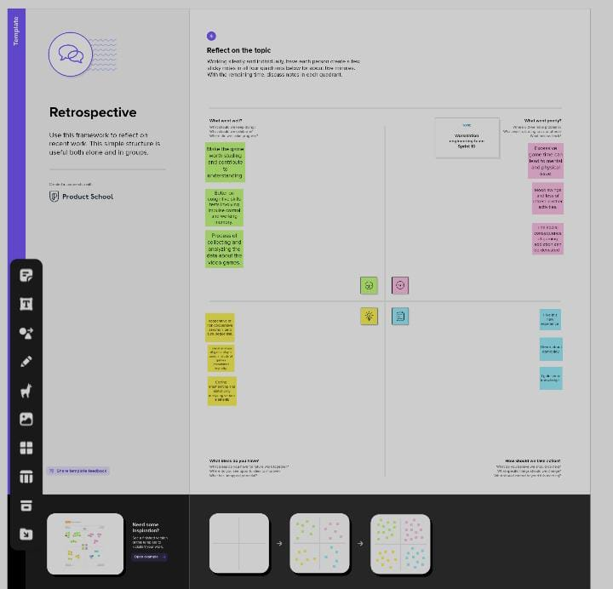

* 1. Ideation & brainstorming Map

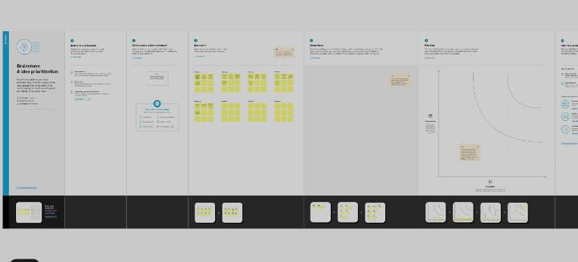

1. **RESULT**



1. **ADVANTAGES & DISADVANTAGES**

Advantages and Disadvantages of Video Games

Advantages of Video Games

1. Improved Vision
2. Brain booster
3. Improved Life Skills
4. May Ease Anxiety and Depression
5. Painkiller

Disadvantages of Video Games

1. Addiction
2. Social Replacement
3. Obesity
4. Stress
5. Could Limit Academic Process
6. Violence

To Conclude

Advantages and Disadvantages of Video Games

It all started in 1952 when British professor A.S. Douglas created OXO, better known as tic-tac-toe at the University of Cambridge. Then Spacewar! came out in 1962, which was the first video game that could be played on multiple computer installations.

1. **APPLICATIONS**

In future we are in analyst that time we want to screen play and game play analyse the Video game this solution is applicable.

1. **CONCLUSION**

The entire work for this project is analyse the video games year by year and the different countries sales . Finding the way to analyse the video game sales by using the project.

1. **FUTURE SCOPE**

The game's scope is a term used to define the project's perceived size and complexity. Without knowing the scope in advance, any production scheduling, costing, and staffing would be nigh on impossible. The scope is usually well defined by the time you wrap up the first version of the game design document.